**Database Rationale**

**Tables / ERD**

Key:

* PK = Primary Key
* FK = Foreign Key
* AI = Auto Increment
* NN = Not Null
* N = Null

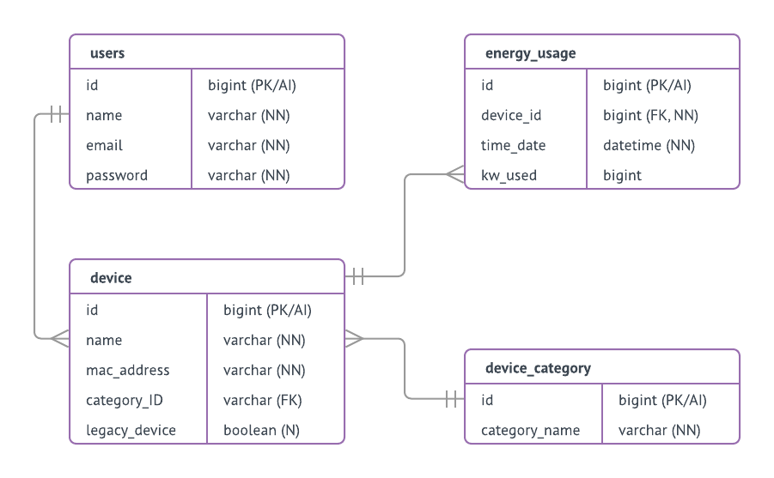

**Design Decisions**

Database Design Decisions

The database was created using MySQL due to our collective knowledge of MySQL, this means creating our tables and queries will be much easier. We have decided to ensure atomicity of each table and removed all partial and transitive dependencies to achieve 3rd Normal Form on all tables. We used Auto Increment on all of the ID’s to ensure that there will never be a duplicate entry which would cause an error and to save shorten the insertion scripts.

All primary keys where named “id” to allow Laravel to automatically find the primary key of the table, this allows queries to function a lot more easily, we did however name the constraints of all primary keys & foreign keys so when the database is used elsewhere other than Laravel the primary keys and foreign keys will be very clear and self-explanatory.

We decided to assign each device a category to allow for possible future expansion of category specific features e.g. the ability to measure other parameters such as temperature or the ability to show the energy usage of a specific category.

**SQL**

